Math 1 Name ______________________________
3-7 Linear Programming Date________
- I can graph linear inequalities on a coordinate plane, resulting in a boundary line (solid or dashed) and a shaded appropriately.
- I can graph and explain that the solution set for a system of linear inequalities is the intersection of the shaded regions of both inequalities.

- Bob builds tool sheds. He uses 10 sheets of dry wall and 15 studs for a small shed and 15 sheets of dry wall and 45 studs for a large shed. He has available 60 sheets of dry wall and 135 studs. Bob makes $390 profit from each small and $520 from each large one.
s = the number of small sheds
L= the number of large sheds.

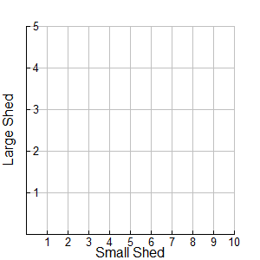
- Write a system of inequalities to represent the constraints of this situation

Dry wall constraint

Studs constraint

- Graph the system of inequalities.
- Find the intersection of the two constraints.

- Pick one coordinate that is a viable solution. _______

- Pick one coordinate that is not a viable solution. _________

- Remember the objective was to find how many of each type of buildings Bob should build to MAXIMIZE his profit. Write an equation to represent the OBJECTIVE FUNCTION.

P =

- Test the vertices into the OBJECTIVE FUNCTION.
Vertices (s, L) | Objective Function P =

- Bob should build _______ small sheds and ________ large sheds to MAXIMIZE his profit.
- A potter is making cups and plates. It takes her 6 minutes to make a cup and 3 minutes to make a plate. Each cup uses ¾ lb. of clay and each plate uses one lb. of clay. She has 1500 minutes available for making the cups and plates and has 300 lbs. of clay on hand. The potter makes $2 profit for each cup and $1.50 for each plate.
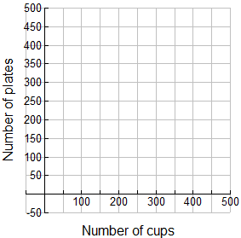
c = number of cups made
p = number of plates made

- Write a system of inequalities to represent the constraints of this situation

Time Constraint

Weight Constraint

- Graph the system of inequalities.
- Find the intersection of the two constraints.

- Pick one point that is a viable solution. ________

- Pick one point that is not a viable solution. _________

- Remember the objective was to find how many of each type of cups and plates the potter needs to MAXIMIZE the profit. Write an equation to represent the OBJECTIVE FUNCTION

P =

- Test the vertices into the OBJECTIVE FUNCTION.
Vertices (c, p) | Objective Function P =

- The potter should make _________ cups and ________ plates to MAXIMIZE the profit.
- Marcus is creating a low-fat pie crust recipe for his pie shop. Butter has six grams of saturated fat and one gram of polyunsaturated fat per tablespoon. Vegetable shortening has one gram of saturated fat and four grams of polyunsaturated fat per tablespoon. The butter and vegetable shortening combine for at least 36 grams of saturated fat and at least 40 grams of polyunsaturated fat. Each tablespoon of butter is 100 calories and each tablespoon of vegetable shortening is 115 calories.

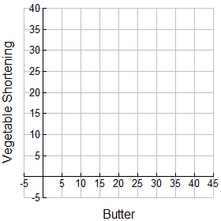
b = butter
v = vegetable shortening

- Write a system of inequalities to represent the constraints of this situation

Saturated Fat Constraint

Polyunsaturated Fat Constraint

- Graph the system of inequalities.
- Find the intersection of the two constraints.

- Pick one point that is a viable solution. ______

- Pick one point that is not a viable solution. ________

- Remember the objective was to find how much butter and vegetable shortening was needed to MINIMIZE the calorie intake. Write an equation to represent the OBJECTIVE FUNCTION

C =

- Test the vertices into the OBJECTIVE FUNCTION.
Vertices (b, v) | Objective Function C =

- Marcus needs _________ tbsp. of butter and ________ tbsp. of vegetable shortening to MINIMIZE the calorie intake.
- Several students at Conway High School decide to hold a concert to raise money for flood victims in a nearby town. They organize people in the community to donate services for the concert, so it will not cost them anything to run the concert. They decide to charge $10 per adult and $8 per student for tickets. The auditorium can hold 800 people. Their goal is to raise at least $2,000.

  - Write a system of inequalities that describes the number of people attending the concert and the amount of money they hope to raise.

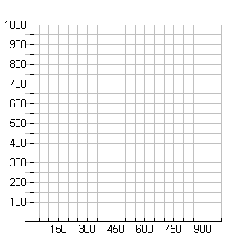
  - Use the grid below, to graph the system of inequalities and shade the solutions.

S
t
u
d
e
n
t
s

Adults

  - Is the point (650, 150) a viable solution? __________ What does the coordinate represent?

  - Is the point (300, 200) a viable solution? __________ What does the coordinate represent?

  - Is the point (600, 400) a viable solution? __________ What does the coordinate represent?

